**Component**

A component encapsulates

* Data
* HTML template
* Logic

In angular component are reusable entities.

We can create components in two ways

1. Manually
2. Using CLI – command line interface

**Manually**

* Creating components manually usually involves 3 steps

1. Create a class component
2. Register it in a module (App Module)
3. Add an element in an HTML markup

**Create a class component –** create a new class inside src/app/recipe.component.ts as below

|  |
| --- |
| import{Component} from '@angular/core'  @Component({      selector:**'recipe'**,      template:'<h4>Recipes will load soon...</h4>',  })  export class RecipeComponent{  } |

**Register it in a module (App Module) –** register the newly created class inside **app.module.ts** under declarations and import as below

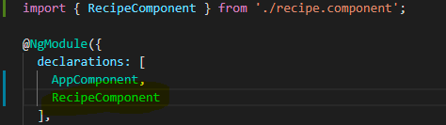

**Add an element in an HTML markup**

Add a mark in any html page using the above selector “recipe”.

e.g) Adding markup in app.component.html as below

|  |
| --- |
| <recipe></recipe> |

**Output:**

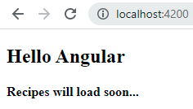

**Using CLI – command line interface**

Adding component using angular cli

|  |
| --- |
| ng generate component <component_name>  e.g) ng generate component cart |

Executing the above command, angular will take care of creating a component class, .html file, .css and .spec.ts test file

Also, it will update and register component in app.module.ts class

